**Milestone 3 Report**

Mohannad Noaman 52-22111

Ziad sherif 52-3407

Ahmed Gobran 52-8677

Mazen Motaz 52-12369

Mohamed Farid 52-5020

Kirolos George 52-3525

**forward Kinematics Code :**

function T = forward_kinematics_func()

% Forward kinematics of a 4-DOF manipulator with symbolic joint angles

% Define symbolic variables for joint angles

syms q1 q2 q3 q4 real

%syms L1 L2 L3 L4 real

%{

% Define constants for joints angles

q1 = deg2rad(90); % Joint 1 angle (degrees to radians)

q2 = deg2rad(45); % Joint 2 angle (degrees to radians)

q3 = deg2rad(60); % Joint 3 angle (degrees to radians)

q4 = deg2rad(90); % Joint 4 angle (degrees to radians)

%

% Define constants for link lengths

L1 = 33.88; % Length of link 1

L2 = 115; % Length of link 2

L3 = 119; % Length of link 3

L4 = 68; % Length of link 4

%{

L1 = 43.55;

L2 = 115;

L3 = 120;

L4 = 68;

%}

% Define the homogeneous transformation matrices symbolically

A = [cos(q1 + pi/2), 0, -sin(q1 + pi/2), 0;

sin(q1 + pi/2), 0, cos(q1 + pi/2), 0;

0, -1, 0, L1;

0, 0, 0, 1];

B = [cos(q2 - pi/2), -sin(q2 - pi/2), 0, -L2 * cos(q2 - pi/2);

sin(q2 - pi/2), cos(q2 - pi/2), 0, -L2 * sin(q2 - pi/2);

0, 0, 1, 0;

0, 0, 0, 1];

C = [cos(q3), -sin(q3), 0, -L3 * cos(q3);

sin(q3), cos(q3), 0, -L3 * sin(q3);

0, 0, 1, 0;

0, 0, 0, 1];

D = [cos(q4), -sin(q4), 0, -L4 * cos(q4);

sin(q4), cos(q4), 0, -L4 * sin(q4);

0, 0, 1, 0;

0, 0, 0, 1];

% Calculate the overall symbolic transformation matrix

T = simplify(A * B * C * D); % Simplify to get a cleaner symbolic expression

%T = A * B * C * D;

disp(T)

% Extract the position of the end effector (fourth column, first three rows)

end_effector_position = T(1:3, 4);

disp(end_effector_position);

j = jacobian(end_effector_position,[q1,q2,q3,q4]);

    disp(j);

end

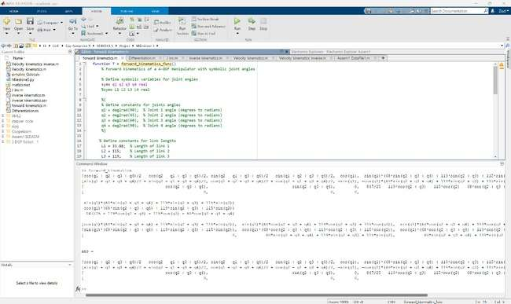

**Jacobian matrix code :**

Jacobian matrix

function J_Matrix = calculate_partial_derivatives()

% Calculate the partial derivatives of the end-effector position with respect to each joint angle

% Get the transformation matrix T from the forward kinematics function

T = forward_kinematics();

% Extract the fourth column elements of the end-effector position

f1 = T(1, 4); %X.E.E

f2 = T(2, 4); %Y.E.E

f3 = T(3, 4); %Z.E.E

%disp(f1);

%disp(f2);

%disp(f3)

% Define symbolic variables for joint angles to use for differentiation

syms q1 q2 q3 q4 real

% Calculate the partial derivatives with respect to each joint angle

partial_q1_f1 = diff(f1, q1);

partial_q2_f1 = diff(f1, q2);

partial_q3_f1 = diff(f1, q3);

partial_q4_f1 = diff(f1, q4);

partial_q1_f2 = diff(f2, q1);

partial_q2_f2 = diff(f2, q2);

partial_q3_f2 = diff(f2, q3);

partial_q4_f2 = diff(f2, q4);

partial_q1_f3 = diff(f3, q1);

partial_q2_f3 = diff(f3, q2);

partial_q3_f3 = diff(f3, q3);

partial_q4_f3 = diff(f3, q4);

% Store results in a matrix for easy interpretation

J_Matrix = [partial_q1_f1, partial_q2_f1, partial_q3_f1, partial_q4_f1;

partial_q1_f2, partial_q2_f2, partial_q3_f2, partial_q4_f2;

partial_q1_f3, partial_q2_f3, partial_q3_f3, partial_q4_f3];

disp(J_Matrix);

% Display results

% disp('Partial derivatives of the end-effector first row, first column with respect to q1, q2, q3, and q4:'); % disp(partial_derivatives);

End

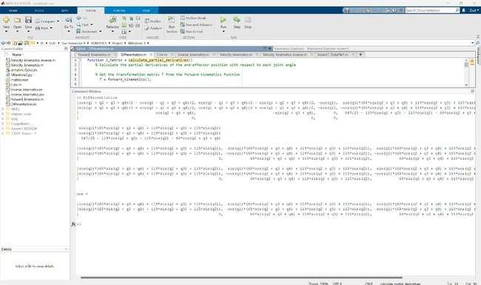

**Jacobian inverse code :**

function J_pseudo_inv = inverse_jacobian_matrix(q)

% Get the Jacobian matrix by calling Differentiation

J_Matrix = Differentiation();

%disp(Diff);

% Calculate the inverse of the Jacobian matrix

J_transpose = J_Matrix';

% Pseudo inverse since the robot is over actuated DOF < DOJ

J_pseudo_inv = simplify((J_transpose)*(inv(J_Matrix*J_transpose)));

% Display the inverse of the Jacobian matrix

disp('Pseudo inverse of the Jacobian matrix (J_inv):');

disp(J_pseudo_inv);

end

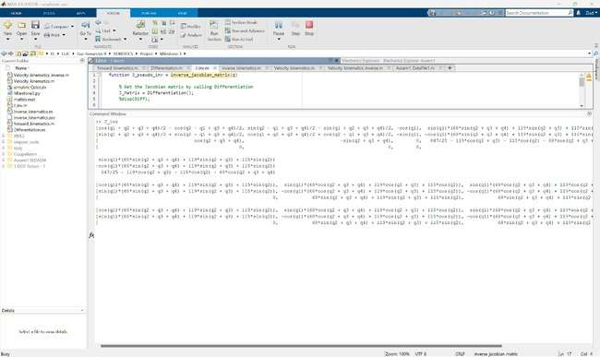

**inverse kinematics Code :**

function q = inverse_kinematics_func(q0, X)

J_pseudo_inv = J_inv();

T = forward_kinematics();

end_effector_position = T(1:3, 4);

f1 = T(1, 4); %X.E.E

f2 = T(2, 4); %Y.E.E

f3 = T(3, 4); %Z.E.E

% Define symbolic variables

syms L1 L2 L3 L4 q1 q2 q3 q4

% Define constants for joints angles

%q1_num = deg2rad(90); % Joint 1 angle (degrees to radians)

%q2_num = deg2rad(45); % Joint 2 angle (degrees to radians)

%q3_num = deg2rad(60); % Joint 3 angle (degrees to radians)

%q4_num = deg2rad(90); % Joint 4 angle (degrees to radians)

% End-effector position matrix in matrix form

x_desired = [178.6628; 0; 49.051];

%disp(x_desired);

% Define F(Qn)

W = [f1; f2; f3];

%disp(W);

F_Qn = W - x_desired;

% Define the joint variables as a vector

% q_new = [q1; q2; q3; q4];

q_old = [1.6; 0.8; 1.1; 1.6];

% Define parameters:

i = 0;

error = 11;

err_toler = 1e-4; % Convergence tolerance

max_iters = 100; % Maximum number of iteration

while(error > err_toler)

q1_num = q_old(1,1);

q2_num = q_old(2,1);

q3_num = q_old(3,1);

q4_num = q_old(4,1);

W_sub = subs(W,[q1,q2,q3,q4],[q1_num,q2_num,q3_num,q4_num]);

F_Qn = W_sub - x_desired;

p_inv_sub = vpa(subs(J_pseudo_inv,[q1,q2,q3,q4],[q1_num,q2_num,q3_num,q4_num]))

q_new = vpa(q_old - (p_inv_sub * F_Qn));

disp('Qnew =');

disp (q_new);

q_old = q_new;

i=i+1;

if (i>100)

disp('Warning: Maximum iterations reached without convergence.');

random_matrix = pi *rand(4, 1);

q_old = random_matrix;

break;

 end

    end

end

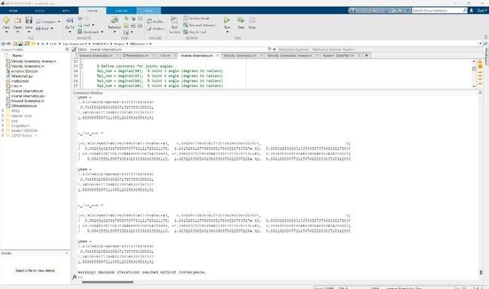

**velocity kinematics Code :**

function V = Velocity_kinematics

coder.extrinsic('syms', 'subs', 'vpa', 'simplify');

syms p1 p2 p3 p4 q1_dot q2_dot q3_dot q4_dot real

syms t q1 q2 q3 q4

J_matrix = Differentiation();

p1 = 0.1 * t;

p2 = 0.3 * t;

p3 = 0.4 * t;

p4 = 0.2 * t;

q1_dot = 0.1;

q2_dot = 0.3;

q3_dot = 0.4;

q4_dot = 0.2;

q_dot = [q1_dot;

q2_dot;

q3_dot;

q4_dot];

tn = 0;

while (tn < 10)

q1_subs = subs(p1,t,tn);

q2_subs = subs(p2,t,tn);

q3_subs = subs(p3,t,tn);

q4_subs = subs(p4,t,tn);

J_matrix_sub = vpa(subs(J_matrix,[q1,q2,q3,q4],[q1_subs,q2_subs,q3_subs,q4_subs]));

V = simplify(J_matrix_sub * q_dot);

disp(V);

tn = tn + 0.1;

end

end

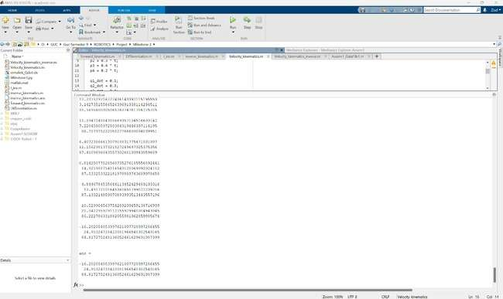

**velocity inverse Code :**

function Q_DOT = Velocity_kinematics_inverse

coder.extrinsic('syms', 'subs', 'vpa', 'simplify');

syms X_dot Y_dot Z_dot real

syms p1 p2 p3 p4 q1_dot q2_dot q3_dot q4_dot real

syms t q1 q2 q3 q4

J_pseudo_inv = J_inv();

V = Velocity_kinematics();

J_matrix = Differentiation();

p1 = 0.1 * t;

p2 = 0.3 * t;

p3 = 0.4 * t;

p4 = 0.2 * t;

X_dot = V(1);

Y_dot = V(2);

Z_dot = V(3);

Q_DOT = [q1_dot;

q2_dot;

q3_dot;

q4_dot];

tn = 0;

while (tn < 10)

q1_subs = subs(p1,t,tn);

q2_subs = subs(p2,t,tn);

q3_subs = subs(p3,t,tn);

q4_subs = subs(p4,t,tn);

J_mat_sub = vpa(subs(J_matrix,[q1,q2,q3,q4],[q1_subs,q2_subs,q3_subs,q4_subs]));

J_inv_sub = pinv(J_mat_sub);

%J_inv_sub = vpa(subs(J_pseudo_inv,[q1,q2,q3,q4],[q1_subs,q2_subs,q3_subs,q4_subs]));

Q_DOT = simplify(J_inv_sub * V);

disp(Q_DOT);

tn = tn + 0.1;

end

end

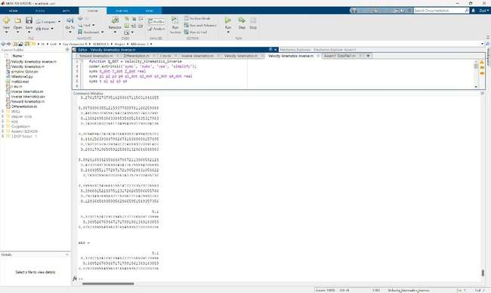

**Simulink simscape Diagram :**

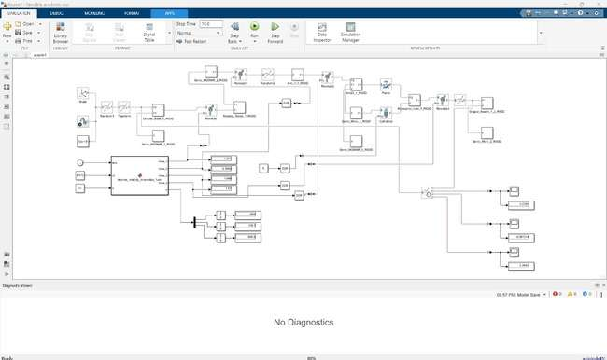

**Copliasim results :**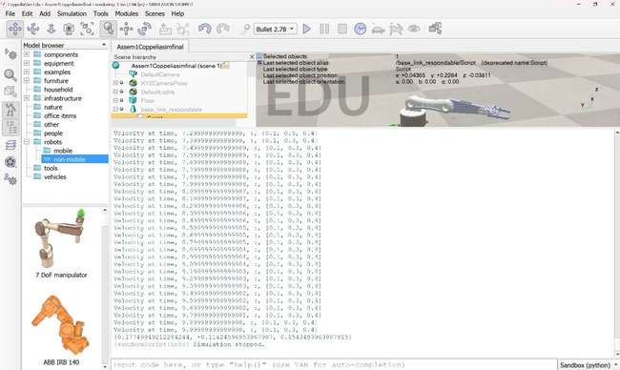

**Circuit diagram :**

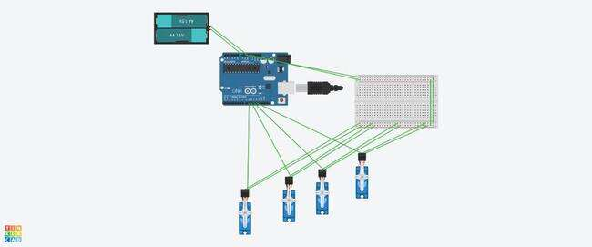

**Hardware :**

